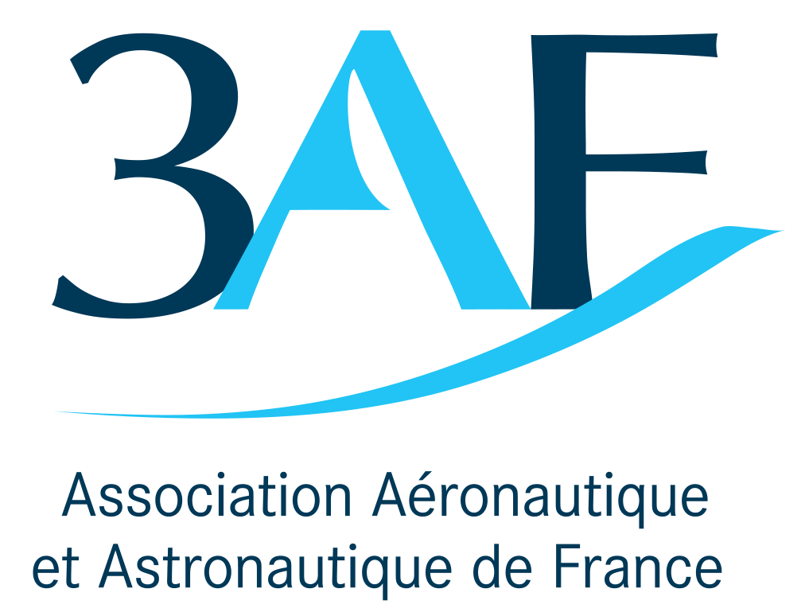 | 59th 3AF International Conference AERO2025-ID-NAME  on Applied Aerodynamics  24 – 26 March 2025, Strasbourg - France

TITLE OF THE ABSTRACT

First Author ⁽¹⁾ and Second Autor⁽²⁾
⁽¹⁾ Affiliation, Complete mailing address (including country), Email:
⁽²⁾ Affiliation, Complete mailing address (including country), Email:

ABSTRACT

The Proceedings of the 59th 3AF International Conference on Applied Aerodynamics will be published online by 3AF only for the delegates.
Authors must deliver their full paper by 03 March 2025 as electronic PDF file.
Please read the following instructions for the preparation of your paper in accordance with 3AF’s standards for conference proceedings. Each submission should resemble these instruction sheets in format and style. Start with a concise abstract (limited to 15 lines or 150 words) that summarises the contents of the paper.

GENERAL SPECIFICATIONS
The paper must be prepared in this two-column format and must not be longer than 10 pages including figures, table and references.

PAGE LAYOUT
- Paper format: standard A4 (297x210 mm),
- Two-column format (8 cm each column),
- Margins: top 25 mm, left and right 20 mm,
bottom 37 mm,
- Fully justified,
- Page numbers centred at the bottom of each page.

Font:
Text: Times New Roman
Variable: Times New Roman italic
Symbol: True Type Symbol font

Type Size:
Paper Id.: 10 pt bold (1st page up-right corner)
Paper title: 14 pt bold (TITLE)
Author(s): 10 pt (Author)
Affiliation(s): 10 pt italic (Affiliation)
Headings: 11 pt bold uppercase

Normal text: 10 pt (regular text)
Captions: 10 pt (Figure…)
Text in tables: 9 pt
Symbols: 10 pt (Ω ≅ φ )
Sub/superscript: 7 pt (x ^{y})
Page number: 10 pt (regular text)

HEADERS AND FOOTERS
The header should be left empty.
Page numbers should be added to the footer.

TITLE AND AUTHOR AFFILIATION
The paper title, author(s) name(s), affiliation, complete mailing address and email should be centred at the top of the first page using the fonts and type sizes indicated above. If there are several authors, the complete affiliation should be given for each of them using superscripts ⁽¹⁾ in the authors ⁽²⁾ list to refer to them.

HEADINGS
This sheet has been typeset in accordance with the style to be followed for the headings. Use the decimal system in Arabic figures for the numbering of headings and subheadings. Major (or section) headings are to be in capitals and bold.

Subheadings
Subheadings or subsection headings are to be in lower case with initial capitals and bold font. They should be flush with the left-hand margin, on a separate line.

EQUATIONS
Equations are to be numbered consecutively throughout the paper. Each equation number must be unique. Equations should be centred, with the equation number in parentheses flush with the right-hand margin of the column. Leave a blank line before and after equations. Always refer to equations by number, as Eq. 1 or Eqs. 3-6, not as ‘above’ or ‘below’.
$T_{s}=\frac{T_{b}}{1+({λT}_{b}/α)\text{ln}ε}$ (1)

FIGURES AND TABLES
Figures and tables can extend over two columns if required. Figure captions should be centred below the figures; table captions should be centred above the tables. Use full word ‘Figure 1’ or ‘Table 1’ in the caption. Use the abbreviation “Fig. 1” or “Tab. 1” in the text (even at the beginning of a sentence).
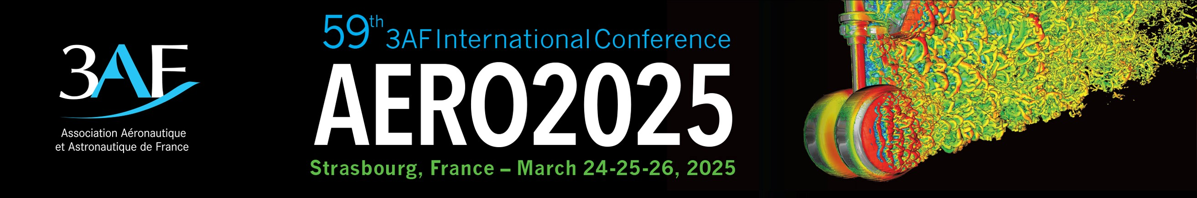
Figure 1. AERO2025

ABBREVIATIONS AND ACRONYMS
Define abbreviations and acronyms the first time they are used in the text, even after they have been defined in the abstract. Do not use abbreviations in the title unless they are unavoidable.

REFERENCES
Number citations consecutively in square brackets [1]. Refer simply to the reference number, as in [3]. Do not use ‘Ref. [3]’ or ‘reference [3]’ except at the beginning of a sentence: ‘Reference [3] was the first …’.
The title of the book or of the journal should be in italic script.

Sample References
1. Smith, J.M., Adams, B.A. & Wilson, A. (2002). The Future for Asteroid Exploration. Planet. Space Sci. 285(11), 123-126.
2. Johnson, A.B. & Radice, X.T. (2002). Comets for Beginners, Cambridge University Press, Cambridge, UK, pp103-106.
3. Svalgaard, L. & LeSager, P. (2003). What Heliosesimology Teaches us About the Sun. In Proc. 4th. ISCS ‘Solar Variability as an Input to the Earth’s Environment’ (Eds. H. Lacoste &
H. Xerxes), ESA SP-535 (CD-ROM), ESA Publications Division, European Space Agency, Noordwijk, The Netherlands.

SUBMITTING THE PAPER
Deadline for submission is:
03 March 2025

Full papers are to be delivered by email to:

aero.conf@3af.fr

The filename must clearly identify the paper.
Use the ID Number followed by the name of the main author (e.g. AERO2025-01-SMITH. pdf).

Your paper number is given in the accompanying letter.

Papers must be delivered by 03 March 2025 at the latest, if they are to be included on proceedings.
For further information about preparing your paper, please send an email to aero.conf@3af.fr

Information available on:

www.3af-aerodynamics.com

